[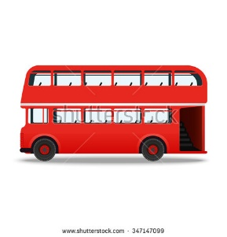](https://www.google.co.uk/url?sa=i&rct=j&q=&esrc=s&source=images&cd=&cad=rja&uact=8&ved=0ahUKEwiH8diy0dLXAhWR5aQKHb1eC54QjRwIBw&url=https://www.shutterstock.com/search/red%2Bbus&psig=AOvVaw2cH-ADAld91-f10ILTmKnD&ust=1511455695349118)[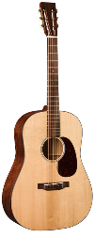](https://www.google.co.uk/url?sa=i&rct=j&q=&esrc=s&source=images&cd=&cad=rja&uact=8&ved=0ahUKEwjZnoz30NLXAhWF6aQKHeRaCnoQjRwIBw&url=https://www.martinguitar.com/guitars/authentic-vintage/d-1-authentic-1931/&psig=AOvVaw21m1KvFRoBkc1p4-SI4zDI&ust=1511455567552890)**Theme 1**

What are these objects? 1. 2.

3. [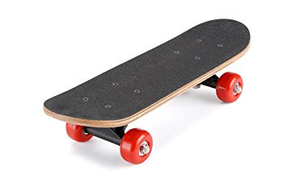](https://www.google.co.uk/url?sa=i&rct=j&q=&esrc=s&source=images&cd=&ved=0ahUKEwi78dfh0dLXAhVSFuwKHT8RAVIQjRwIBw&url=https://www.amazon.co.uk/Osprey-Mini-Skateboard-Multicoloured-Assorted/dp/B003N90B4A&psig=AOvVaw0ee26iBx-wLl4AB-PP4SEL&ust=1511455791869547)[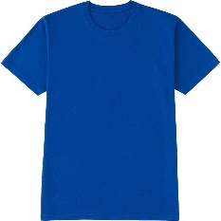](https://www.google.co.uk/url?sa=i&rct=j&q=&esrc=s&source=images&cd=&cad=rja&uact=8&ved=0ahUKEwiLjLyO0tLXAhUE16QKHYHpD1wQjRwIBw&url=https://www.uniqlo.com/us/en/men-packaged-dry-crew-neck-short-sleeve-t-shirt-146209.html&psig=AOvVaw1sV9pjeRE8_0tFAzC5qfRy&ust=1511455887344376) 3. 4.

Translate the words!

* Haus
* Garten 
* Glücklich 
* Freundlich 
* Spielplatz 
* Shop 
* Neighbourhood 
* Swimming pool 
* Big 
* **[](https://www.google.co.uk/url?sa=i&rct=j&q=&esrc=s&source=images&cd=&cad=rja&uact=8&ved=0ahUKEwi_rZCk2dLXAhUS56QKHTJ5BeMQjRwIBw&url=https%3A%2F%2Fwww.dreamstime.com%2Froyalty-free-stock-image-cute-little-girl-image10077796&psig=AOvVaw0-FNJIxMLmnUh2KWqRIswM&ust=1511457809223004)**Parents 
* My name is Jessica.
* I am from Berlin.
* I am 12 years old.
* I have got a blue hat.
* I have one brother and one sister.
* Their names are Nick and Sally.
* I love salad but I hate tomatoes!
* My favourite hobby is dancing.
* I have 3 cats. My favourite colour is blue.

Jessica is from

Jessica has got one and one 

Jessica loves 

But she hates 

Jessica has got a blue 

Match the questions and answers.

Does Jessica have 3 cats? a) yes, it is

Are her brother and sister called Lucas and Sally? b) yes, she does

Is blue her favourite colour? c) no, they aren’t

Is her favourite hobby swimming? d) no, it isn’t